
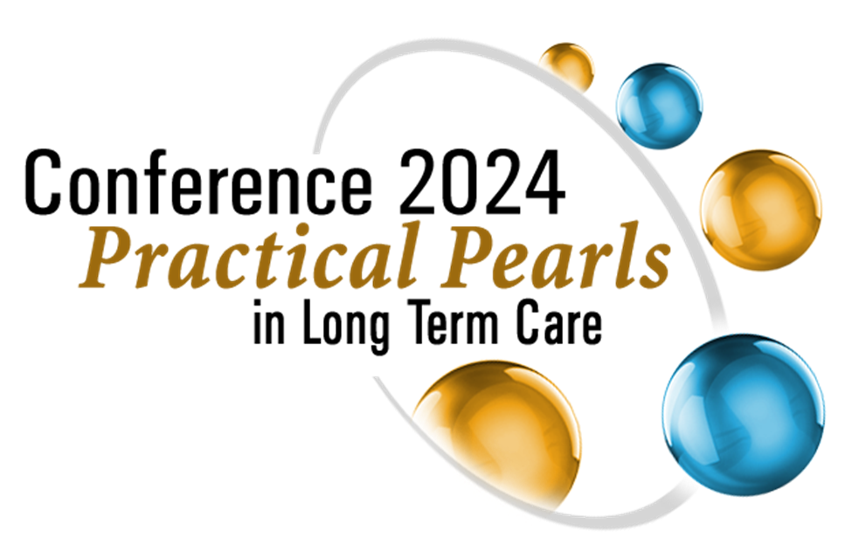

CALL FOR POSTERS
LONG TERM CARE FOR PRACTICING CLINICIANS – CLINICAL PEARLS IN LTC
HILTON HOTEL
TORONTO, ONTARIO
FRIDAY, OCTOBER 25 – SUNDAY, OCTOBER 27, 2024

Please complete all areas of this form and return to: office@oltcc.ca

DEADLINE DATE: FRIDAY, SEPTEMBER 13, 2024

OVERVIEW
The 2024 conference will be held at the Hilton Hotel, in Toronto from October 25 to 27, 2024. Friday, October 25, 2024, is reserved for Half-Day & Full Day Workshops. The conference program will run Saturday, October 26 and Sunday, October 27, 2024. Posters will be on display Friday, October 25 through to Sunday, October 27, 2024.

POSTER SET UP AND ATTENDANCE
Posters will be set up Friday, October 25, 2024, by 12:00 pm. Posters will remain up until the program ends on Sunday, October 27 at 1:30 pm. You will be asked to set up and tear down at these times. You are not required to attend your poster at any time, however if you choose to register for the conference and be available at your poster during breaks/lunch etc., that would be your choice.

POSTER PROJECTS
Posters should demonstrate a research or quality improvement project, best practice, or a clinical case illustrating a relevant underlying concept of caring for older adults in Long-Term Care. The Conference Planning Committee invites proposals for the 2024 conference.

POSTER DETAILS
When your poster has been accepted, you will be sent the information on set up, tear down, size, location etc. and anything else you may need to know for your poster presentation at the conference.

POSTER INFORMATION

PRESENTER’S CONTACT INFORMATION:
Email:
Phone Number:

SUBMISSIONS SENT TO: Only by email to office@oltcc.ca

WHY THE RESEARCH / QI QUESTION, BEST PRACTICE OR CLINICAL CASE IS RELEVANT TO LTC
Include a clear statement of goals and objectives – maximum 75 words

POSTER ABSTRACT, Please complete all sections below for the poster abstract
Maximum 250 words – maximum does not include spaces or title or author listings

POSTER TITLE, Bold and all Caps

FIRST AUTHOR, Plus all credentials and affiliations

OTHER POSTER AUTHORS, Plus credentials and affiliations

PRESENTER’S EXPERIENCE:

ABSTRACT
Maximum 250 words, not including spaces

WHY IT IS RELEVANT FOR CLINICIANS IN LONG TERM CARE
Maximum 75 words

QUESTIONS? OLTCC Office: 905-404-9545 or office@oltcc.ca

